Unit 4
Chapter 8

HOMEOSTASIS
Homeostasis: The maintenance of a relatively constant internal environment with small tolerance limits, despite changes in the external environment.
- Organisms have structural features, behavioural responses and physiological mechanisms to help maintain a constant internal state.
- Organisms communicate constantly with their environment (external and internal).

DETECTING STIMULI
The principles of communication include:
- the production of a signal that contains information to be transferred;
- the detection of the signal;
- the transfer of the signal to the target;
- a response to the signal by the target;
- the ‘switch off’ of a signal once it has been responded to.
Signals come from external environment, other parts or organism or within the cell.
- Stimuli may be physical (e.g. light, heat, pressure) or chemical (e.g. hormones, neurotransmitters).
- External and internal receptors allow organisms to respond to stimuli.
- There are five main types of receptor: chemoreceptors, mechanoreceptors, photoreceptors, thermoreceptors and pain receptors.

EXTERORECEPTORS (multicellular organisms)
- exteroceptors: receptors that are highly specialised to receive signals from the external environment
- Exteroceptors work by receiving information and converting it to chemical signals that can be relayed between body cells.
- Exteroceptors can be distributed:
  - evenly over the body (e.g. pain receptors);
  - in specialised areas (e.g. taste buds);
  - concentrated in organs (e.g. the eye).

INTEROCEPTORS
- Interceptor receive from within the body’s internal environment. → An internal signal could be the increase in CO2 levels or low pH levels.
- The internal environment is created by interstitial fluid (bathes cells & exchanges substances across membranes) and blood plasma.
- Aid of interceptors: the internal environment is maintained within narrow limits for maximum cellular efficiency.
EXAMPLES OF EXTEROCEPTORS AND INTEROCEPTORS

Receptor | Stimuli | Location
chemoreceptors | exteroreceptors: smell (olfactory | nose, mouth
 | receptors) or taste.
 | interoceptors: detection of | aorta, carotid arteries.
 | oxygen and ion levels
mechanoreceptors | exteroreceptors and | ear, skin
 | interoceptors: pressure, touch,
 | tension and sound vibrations.
photoreceptors | exteroreceptors: light | eyes and light-sensitive cells
thermoreceptors | exteroreceptors: external | skin
 | temperature variations
 | interoceptors: internal | hypothalamus
 | temperature variation
pain receptors | exteroreceptors and | free nerve endings in the skin
 | interoceptors: pain

HOMEOSTASIS SYSTEMS
- The nervous and endocrine systems are responsible for monitoring changes and co-ordinating responses in complex organism.

NERVOUS SYSTEM
- The nervous system is comprised of the central nervous system (CNS) and the peripheral nervous system (PNS).
- The CNS is formed by the brain and spinal cord.
  - The CNS is responsible for processing, storing and co-ordinating information.
- The PNS is made up of all other neurons.
  - The PNS transmits information to and from the CNS.

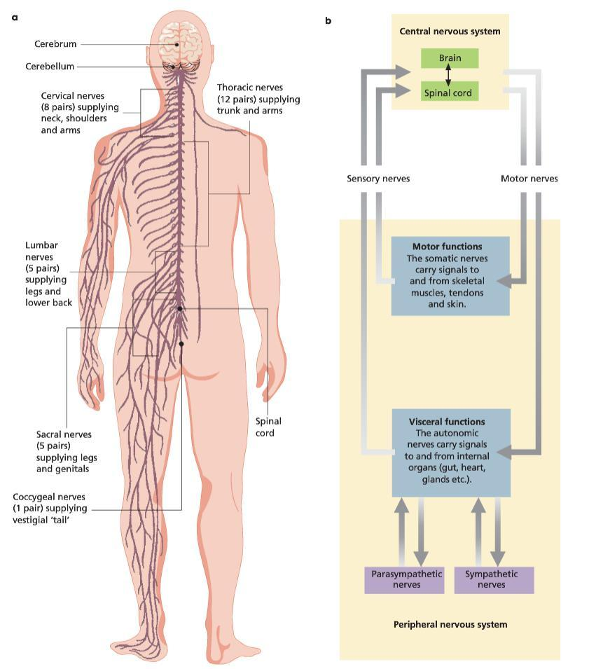

NEURAL PATHWAYS
- Impulses follow sensory neurons from the source of stimulation via the PNS to the CNS.
- Impulses are then relayed (from sensory neurons) via interconnecting neurons to the appropriate motor neurons.
- Motor neurons relay the signal via the PNS to effectors (muscles/glands that respond to the stimuli).

NEURONS
- Neurons are the basic units of the nervous system.
- Neurons consist of fibres which contain a tubular extension called the axon.
  - The axon is enclosed in a fatty material called the myelin sheath.
- Myelin is composed of Schwann cells.
  - Schwann cells wrap around the fibre, leaving small nodes along the axon.
  - This assists in transmission; more myelin means faster conduction.
  - Oligodendrocytes create protecting nodes around the interconnecting tissues.

VOLUNTARY/INVOLUNTARY RESPONSES
- The nervous system is responsible for rapid responses to changes in the environment.
- Some responses are voluntary, others are involuntary.
  - Nerves involved in voluntary responses make up the somatic system.
  - Nerves involved in involuntary responses make up the autonomic system.
- Involuntary responses are only recognised when something goes wrong.
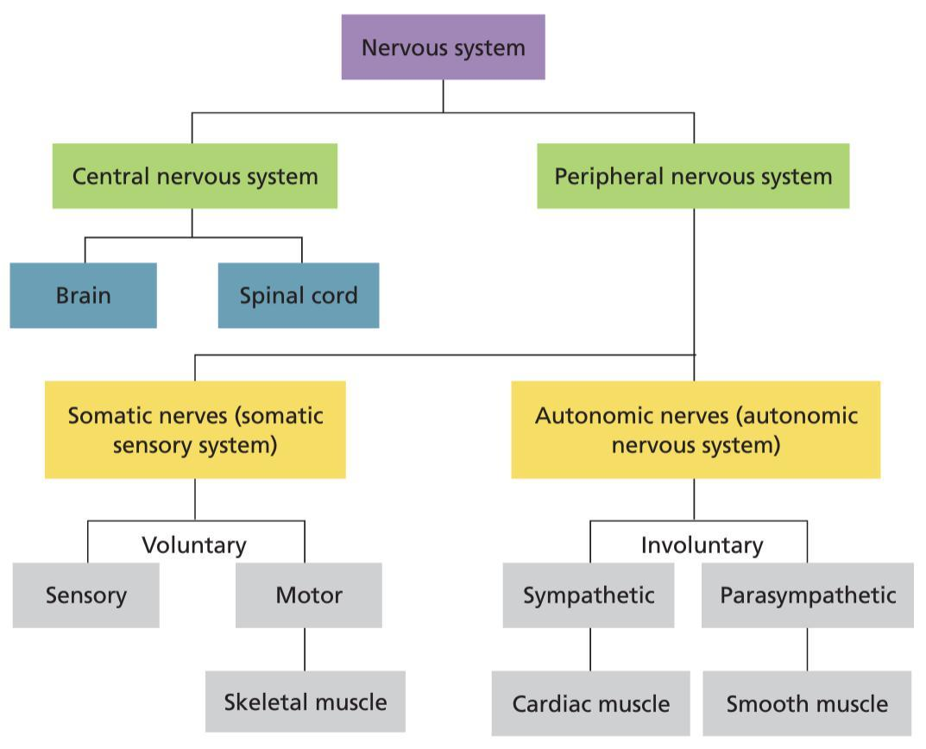

ENDOCRINE SYSTEM
- Some changes are slow and under control of hormones.
  - Not all stimuli require immediate response.
- Hormones are chemical substances (proteins, fatty and amino acids etc.) from the endocrine system.
- In vertebrates, they are secreted through ductless glands directly into the bloodstream.
- Hormones target and activate certain cells and organs, causing a response.
  - Cells must have specific receptors.

HORMONE EFFECTS
- Some are temporary (e.g. adrenaline), some are longer (e.g. development of a foetus).
- The coordination of activities is often connected to pituitary gland.
  - This produces many hormones that affect hormone production by other glands.
- In other animals:
  - Female ring doves coo to release hormones for egg development.
  - Light sensitive hormones called auxin is responsible for plant growth towards light to maximise their photosynthesis abilities.

IMPORTANCE OF RESPONSE
- Responding to signals is essential for the developmental processes, growth and reproduction of organisms and cells.
  - Failure in signalling pathways can lead to uncontrolled cell growth. → Failure to respond to apoptosis can lead to malformations.
  - Differentiation of stem cells during reproduction occurs from internal and external responses.
- Homeostasis requires the response of signals.
- The ability to keep substance concentrations equal, the movement of materials and the activities of enzymes require responses to correct these changes back to normal.
  - This is essential as biochemical process can be disrupted or cells can be killed.
- Responding to signals is essential to surviving challenges in the external environment.

  - Avoiding injury and death (e.g. predation or falling objects) is crucial to an organism’s survival.

THE PRINCIPLE OF FEEDBACK
- Organisms have narrow ranges for internal temperature and fluid concentrations.
  - Minor fluctuations always occur (e.g. disease, trauma).
  - Disturbances must be controlled quickly for cells to function effectively.
- Signals about disturbances are fed to a control centre.
- The centre interprets and co-ordinates specific responses that counteract or reinforce disturbances.
- These processes are called feedback mechanisms.
- Feedback mechanisms are triggered when a stimulus is detected by a receptor, which is then processes and conveyed to an effector, carrying a response.
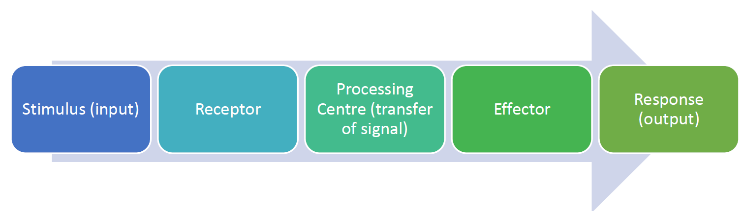
CONTROLLING RESPONSE
- Once signals are responded to, it must be switched off (otherwise it wastes energy/cells are damaged).
- To control a response, a cell or organism can:
  - disrupt the signal pathway
  - remove the original stimulus
  - respond in a way that alters the original signal (ie. feedback).

TYPES OF FEEDBACK
- Negative feedback: mechanisms that counteract a stimulus.
  - Important to restore the internal environment to a constant set of conditions.
  - Eg: Eating chocolate leads to increase blood glucose, the body responds by removing the glucose from the blood and converting it to glycogen.
- Positive feedback refers to mechanisms that reinforce the original stimulus.
  - Eg: As thyroxin rises in tadpoles, positive feedback allows for a rise in thyroxin concentration allowing metamorphosis from tadpole to frog.
- Positive feedback can be harmful.
  - Eg: Increased temperature during fever can lead to a higher set point for temperature which can lead to heatstroke
TOLERANCE RANGE
- A tolerance range is a set range in which different levels of materials, pressure and temperature can be tolerated.
- Homeostasis maintains levels within an optimum range.
- If homeostasis fails, organisms can fall into a state of psychological stress.

METABOLIC ACTIVITY
- Metabolism
  - sum of chemical reactions that occur in an organism to maintain life.
  - Most reactions require enzymes (which function at particular pH/temperatures).
- Metabolic activity creates internal body heat
  - increased activity results in increased temperature.
- These aspects are all connected
  - increase in CO2 → decrease in pH → decrease in enzyme function → decrease in metabolism → decrease in internal body temperature.

PHYSIOLOGICAL PROCESSES
- Physiological processes aid in the regulation the body during exercise.
  - Increase in breathing rate to remove CO2.
  - Thermoreceptors signal for sweat glands to operate to lower body temperatures. ▪ Structural features and behaviour also regulate the body during exercise.
  - Removing clothing or moving into shade are behaviours seen when individuals notice an increase in body temperature.

THERMOREGULATION: The maintenance or regulation of temp; the maintenance of a particular temp of the living body
- Different animals have different internal temperatures.
- These temperatures are where their enzymes work most efficiently (ie. optimum temperature).
  - If internal temperatures rise too much, enzymes denature and metabolic processes fail causing hyperthermia.
  - If internal temperatures fall, enzyme function slows significantly causing hypothermia.

ENDOTHERMS
- Retain heat generated by metabolic activity in their bodies
  - Usually Homoeothermic
    - Can maintain a relatively constant body temperature

ECTOTHERMS
- Depend on absorbing heat from external environment

  - Usually Poikilothermic
    - Cannot control internal temperature – fluctuates with surroundings

 | Homoeothermic | Poikilothermic
Endotherms | humans, wombats and | Yellow-finned tuna, bees, butterflies
 | kookaburras.  Retain heat generated from metabolic activity and can maintain constant body temperature. | Cannot control heat (fluctuates) but keep heat from metabolic activity
Ectotherms | Desert lizards and tropical marine | Snakes, lizards, frogs and toads,
 | invertebrates (cleaner shrimp etc.)  Can maintain relatively constant body temperature | invertebrates and fish.  Cannot maintain control internal body temperature, and depend on the environment

STRATEGIES AND ADAPTATIONS FOR THERMOREGULATION
- Heat transfer depends on the temperature gradient between the internal and the external environment.
- The purpose of thermoregulation is to find heat balance (balance between heat loss and heat gain).
- This usually involves the interaction of an organism’s physiology and their behaviour.
HEAT LOSS AND HEAT GAIN
- An organism may gain or lose heat in a combination of four ways:
  - conduction: the transfer of heat from a hotter object to cooler object by direct contact.
  - convection: the transfer of heat when hot air/water rises and is replaced by cooler air/water.
  - evaporation: when water/sweat turn to vapour, cooling the skin.
  - radiation: when heat is transferred from object by infrared waves.

STAYING COOL IN THE HEAT
- Endothermic homeotherms (those that maintain internal body temperatures and retain heat from metabolic activity) need to be able to reduce heat gain and increase heat loss
ADAPTATIONS FOR HEAT LOSS
Adaptation | Response | Effect
physiological | vasodilation | arterioles widen to increase blood flow to
 |  | the skin where heat can evaporate
 | sweating | water evaporation increases cooling from
 |  | the skin
 | metabolic processes stay steady until | metabolism produces internal body heat
 | body’s cooling mechanisms fail.
behavioural | shelter from high temperatures | reduced contact with higher temperatures
 |  | can reduce temperature gain
 | lick wrists where blood vessels are | increases evaporation from the surface
 | dense | and cools the surface, cooling the blood
 | submerge in water | reduces body temperature by direct
 |  | contact with cooler water
 | lay/spread out | increased surface area increases heat loss
 | moulting | reduced hair reduces the ability to hold
 |  | heat, reducing heat gain
structural | smaller animals live in warmer | increased surface area to volume ratio for
 | climates | heat loss.
 | larger ears | increases surface area
 | light colour hair/fur | reflects light to reduce heat gain
ADAPTATIONS FOR HEAT GAIN
Adaptation | Response | Effect
physiological | vasoconstriction | arterioles constrict to limit blood flow to
 |  | extremities (ie. hands and feet)
 | piloerection | arrector pili muscles contract, raising hair
 |  | in order to trap layer of air to act as
 |  | insulator
 | counter-current heat exchange | blood in arteries to foot/fins, warms blood
 |  | returning in veins (penguins)
behavioural | huddling | decreases overall surface area exposed to
 |  | elements (penguins)
 | nests not usually made | young must huddle against parents which
 |  | decreased SA:V ratio for heat loss
 | migration | movement to different climates that are
 |  | adequate for survival
structural | feathers, fur and fat | acts as an insulating layer
 | larger animals in cool environments | decreases SA:V ratio for heat loss
 | small ears | minimise SA for heat loss

HIBERNATION AND AESTIVATION
- In very cold conditions, an increase in metabolic rate may be insufficient to maintain body temperature within tolerance limits.
- During hibernation, the metabolic rate falls to a level that just sustains life.
- In very dry conditions, aestivation occurs much like hibernation.
  - Eg: Snails retreat into their shell and seal off.

UPPER AND LOWER CRITICAL LIMITS
- A lower critical limit is a temperature where metabolic rate rises, increasing heat output.
- An upper critical limit is a temperature where a body’s cooling mechanisms fail and metabolic rate increases with external temperature.

WATER
- Water is a universal solvent and is essential to life.
- Most salts and minerals are broken into ions by water, creating aqueous solutions.
- Metabolic reactions occur in solutions composed of water.

OSMOREGULATION
- Water balance requires continuous homeostatic control, or osmoregulation.
- When supply does not meet demand, the concentration of solute versus the concentration of solvent is tissue fluids becomes difficult to regulate.
- Physiological functions are then affected:
  - A loss in blood volume leads to pressure drops.
  - Wastes are not excreted efficiently.
  - Enzyme function is affect.
  - Dehydration can lead to death or the collapse of shoot systems (plants).

KIDNEYS
- Kidneys are important for homeostasis and osmoregulation.
- Their osmoregulatory function includes:
  - the removal of nitrogenous wastes;
  - the regulation of water concentration in the blood;
  - the maintaining of ion levels in the blood.

NITROGENOUS WASTES
- Nitrogenous wastes are forms via deamination (the removal of an amino group from an amino acid).
- Ammonia (and its conversion, urea) are toxic and affects cell pH.

freshwater fish | lots of dilute urine with ammonia is excreted
 | quickly and continuously to prevent build up.
marine fish and terrestrial animals | convert ammonia to urea and is released as urine
 | (small amount)
reptiles and birds | produce uric acid, the least toxic form of
 | nitrogenous waste with very little water.

KIDNEY OSMOREGULATION
- Kidney osmoregulation is controlled by an antidiuretic hormone (vasopressin).
  - Vasopressin is secreted from neurosensory cells in hypothalamus when osmoregulators detect increase in blood solutes.
- Osmoregulation increases the permeability of distal tubule (kidney).
  - As water concentration increases in blood plasma, negative feedback decreases release of vasopressin.

OSMOREGULATORS AND OSMOCONFORMERS
- Different organisms have various ways to maintain water balance.
- Osmoregulators regulate osmotic concentration to be higher or lower than the external environment.
- Osmoconformers allow osmotic concentration to be equal to external environments.

STRUCTURAL FEATURES OF OSMOREGULATORS
- Osmoregulators have a waterproof/impermeable outer layer to reduce water loss.
  - Scales, hair, feathers and the epidermis are examples of this outer layer.
  - Longer loops of Henle.
- Animals are osmoregulators and have adaptations to aid in osmoregulation.
Eg: High densities of sweat pores in highly exposed areas.
- Plants are also osmoregulators, however water is constantly lost through the stomata. Therefore, structural adaptations include:
  - thick waxy cuticle on the leaf surface
  - reduced numbers of stomata on top of leaf & increased numbers on bottom of leaf
  - sunken stomata
  - hairs on leaves
  - cylindrical or rolled leaves.

PHYSIOLOGICAL PROCESSES OF OSMOREGULATORS
- Osmoregulators have highly specialised mechanisms for regulating internal water and solute concentrations, despite concentration changes in the external environment.
- These are some examples of physiological processes that help in osmoregulation:
  - reabsorption of water from kidney
  - excretion of nitrogenous wastes as urea or uric acid
  - slower production of urine
  - antidiuretic hormone (vasopressin)
  - metabolising fat to produce water

BEHAVIOURAL ADAPTATIONS OF OSMOREGULATORS
- Examples of behaviours of osmoregulators include:
  - burrowing
  - hibernating
  - aestivation (the prolonged dormancy of an insect, fish or amphibian during dry periods).

AQUATIC ORGANISMS
- Marine organisms
Problems:
- hypotonic to surroundings.
  - blood has higher water concentration than surrounding sea water.
- sea water passes through mouth & over gill membranes, water molecules diffuse out of blood into the sea water by osmosis.
- These fish must replace the water which they constantly lose by osmosis
  - Drinking sea water brings a large quantity of salt into the blood and this has to be removed.
Solutions:
- To replace the water they lose, saltwater fish drink sea water.
- To produce a small volume of urine they must have a low rate of filtration of water into the kidney tubules.
  - This is done by having a kidney with relatively few small glomeruli.
- Salt is removed by chloride secretory cells in the gills, which actively transport salts from the blood into the surrounding water.

- Freshwater organisms
Problems:
- hypertonic to their surroundings.
  - blood has lower water concentration than surrounding fresh water.
- As fresh water passes through mouth over gill membranes, water molecules diffuse from fresh water into the blood by osmosis.
- Fish must produce very large volume of urine to balance large intake of water.
  - This large volume of urine carries salt with it, and the salt has to be replaced.

Solutions:
- To produce a large volume of urine the fish must remove a large volume of water from the blood by having a high rate of filtration into the kidney tubules.
- This is done by having a kidney with many large glomeruli
  - capillary networks from which fluid is filtered at the start of the kidney tubules.
- Salt replacement is solved by chloride secretory cells in the gills, which actively transport salts from the surrounding water into the blood.

OSMOCONFORMERS
- Osmoconformers include most marine invertebrates.
- Interstitial fluid concentration fluctuates to match the external environment.
- Fluids are said to be isotonic (ie. the same concentration).
- Organisms, known as euryhaline species, can tolerate fluctuations in salinity, (found in estuaries).

Xerophytes:
- Adaptations to survive environment with little liquid water & high temperatures. EG: desert

Adaptation | Response | Effect
physiological | Leaves curl in hot weather | minimise surface area exposed- reduces water loss.
 | Photosynthetic efficiency | In droughts, photosynthesis occurs early in the morning so stomates remain closed most of the day when temp is highest
 | Rapid life cycle | during wet weather, flowering & seed formation takes place within a few weeks. Seeds remain dormant until next rain.
behavioural
structural | Extensive root system | Maximise water absorption
 | Stomata on underside of leaves only | minimise water loss
 | Small/spine leaves | reduces surface area:volume ratio, minimising amount of water lost in transpiration

Halophyte:
Adaptation | Response | Effect
physiological | Germination in wet weather | Seedlings surrounded by less saline conditions
 | Store salt in seed coat | Limits salt contact with the embryo
 | High salt tolerant cells | Tolerate high saline levels than non- halophytes
behavioural
structural | Salt glands on leaves | store salt, when levels become too high leaves shed
 | Root epidermis | excludes salt ions from entering plant
 | Special vacuole in cells | stores salt, excludes it from rest of cell

Chapter 10
DISEASES
- disease: any condition that interferes with how an organism functions.
- Infectious diseases: caused by invasion by a pathogen and can be transmitted.
- An infected organism is known as the host.
- Pathogen: An infectious agent/organism that causes disease.
  - viruses, bacteria, fungi, protists and parasites.
- Transmission: passing of disease from an infected host to another individual.
- Easily transmitted diseases are contagious.

NON-INFECTIOUS DISEASES
- Non-infectious diseases are not caused by pathogens.
- Non-infectious diseases are not communicable (transmissible).
  - Eg: Nutritional diseases (such as obesity), genetic diseases (such as haemophilia) and autoimmune disease (such as multiple sclerosis).

THE NATURE OF DISEASE
- Most microorganisms are not pathogenic.
- Microorganisms are pathogenic if:
  - they stick to or invade the cell;
  - produce toxins;
  - copes with or avoids the immune system.

VARIATIONS IN PATHOGENS
- Pathogens differ in their pathogenicity (disease-causing ability).
- Virulence: the intensity of a pathogen’s effect.
- Susceptibility to a pathogen: some have greater resistance than others.
- Individual’s ability to avoid being affected by pathogen depends on age, state of health and natural resistance to particular pathogen.

SYMPTOMATIC PERIOD
- Symptoms are the effects of a pathogen on the host.
- Symptoms are usually characteristics of the disease.
  - They can be used to diagnose the pathogen.
INCUBATION PERIOD
- Symptoms do not appear immediately.
- Incubation period: the time between infection and the onset of symptoms.
- This ‘time lag’ occurs because:
  - pathogens may need to divide;
  - may take time to reach target tissue;
  - toxins take time to accumulate.
- Disease is often contagious before symptoms occur.
  - incubation periods may be an adaptation by the pathogen (before symptoms occur).

VIRUSES
Structure:
- Smaller than bacterium
- DNA or RNA core
- Nucleic acid core surrounded by protein coat/2 protein coats
- Protein coats may be covered by lipid layer
- Not cellular/ no organelles

- A virus infects an organism when it injects its nucleic acid into a host cell.
- Viral nucleic acids then direct the host cell machinery to produce viral proteins and viral DNA copies
- These are then assembled into new viruses and are emitted during cell lysis (process of cell bursting)

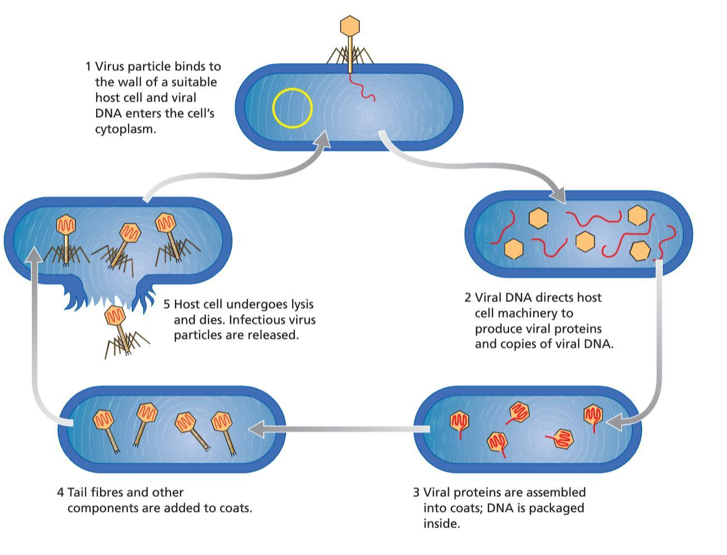
VIRAL DISEASES
- All viruses cause disease.
- Viruses rely of the host cell to complete its life cycle.
- A virus cannot function outside of the host cell and is, therefore, called an obligate parasite. → This trait poses limitations in viral research.

VIRAL PHASES
- Some viruses do not cause host cells to make copies immediately.
- Instead they enter two phases, the lysogenic phase and the lytic phase.
- lysogenic phase:
  - don’t produce viruses immediately
  - viral nucleic acid is integrated with the host’s chromosome;
  - viruses replicate with the host cell, remaining dormant (avoiding detection by defence mechanisms); ▪ The only way to remove the virus is to kill the host cell
- lytic phase is usually entered due to environmental factors.
  - The virus exits the host’s genome and carries on with assembling new viruses.

VIRUS SPECIFICITY AND SUSCEPTIBILITY
- Each virus is highly specific to the host cell/organism it can infect.
- Virus specificity is usually defined by the receptors in the host cell.
  - Eg: Adenovirus specifically infects lung epithelial cells (causing the common cold)
    - able to recognise and bind to receptors only expressed on lung epithelium.
- All organisms are susceptible to viruses.
PRIONS
- Small infectious protein
- Brings about degeneration of the nervous system & ultimately death
- Prions don’t possess any genetic material (DNA or RNA)
- Smaller than viruses
- Prion proteins exist normally in bodies, play important roles in memory, learning & passing signals from cell to cell.
- Located at surface of neurons
- 2 forms: normal prion protein cellular form, PrP^{c} & disease causing prion protein scrapie form, PrP^{Sc}
  - PrP^{Sc} meets PrP^{c} converts to harmful form, then converts other normal forms to harmful forms.
  - When sufficient numbers of pathogenic PrP^{Sc} forms, they aggregate to form filaments. Fibres kill brain cells, affecting muscle coordination & brain function.
BACTERIA
Structure:
- Bacteria are a cellular agent, only a small number cause disease (ie. most are not pathogenic).
- Bacteria are prokaryotes
  - no membrane bound organelles or nucleus
  - possess ribosomes, plasmids and a single circular chromosome.
  - Cell wall: made of sugars & amino acids
  - plasma membrane
  - single celled, microscopic organism
Adaptations:
- Bacteria can survive in tougher, dormant form called an endospore are resistant to extreme temperatures and chemicals.
  - adaptation helps in dispersal and resistance.
- Slimy bacterial capsule, adaptation helpful in sticking to surfaces.
- Some bacteria possess flagellum which help movement.
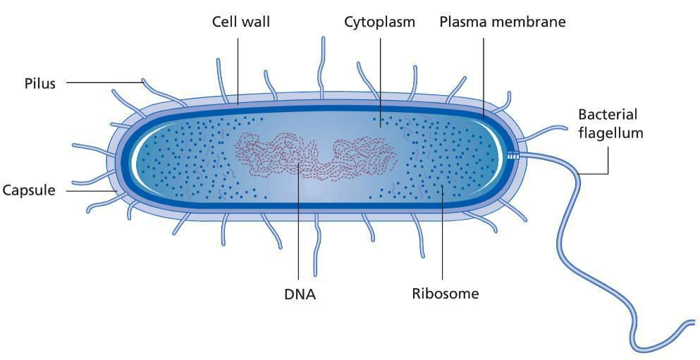

- Bacteria can reproduce by binary fission or by budding off spores.
  - allows bacteria to reproduce very rapidly in favourable conditions.

BACTERIAL CLASSIFICATION AND IDENTIFICATION
- Bacteria can be classified by their shape, cluster or strain.
shape | ▪ coccus (spherical)
 | ▪ bacillus (rod)
 | ▪ spirilli (spiral)
 | ▪ vibrio (comma)
cluster | ▪ diplococci (two)
 | ▪ streptococci (chains)
 | ▪ staphylococcus (clusters)
strain | ▪ gram positive (purple)
 | ▪ gram negative (pink)
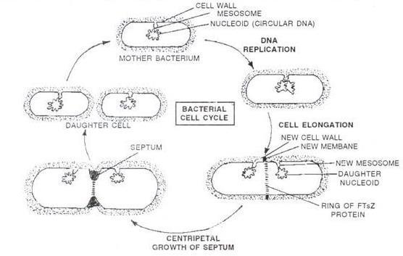

CAUSES OF BACTERIAL DISEASE
- Bacteria transmitted via direct contact, in food and water, and in droplets of moisture in the air.
- Once inside the host, bacteria divide rapidly.
- Some bacteria damage the host tissues directly, or release toxins, whilst others interfere with the immune system.

FUNGI
Structure:
- Mostly multicellular
- eukaryotes that reproduce using spores.
- Cell walls are made of chitin (carbohydrate)
- Consist of branching threads called hyphae, form mass called mycelium.
- Hyphae divided by septa
  - have pores in them to allow nutrients to pass from 1 cell to next
- Not all fungi are pathogenic.

External Fungal Diseases
- Most fungal diseases in animals are external.
  - diseases irritate or inflame the skin.
- As they grow on the skin, fungi produce spores.
  - Infected skin flakes off, carrying spores with it.
  - If these spores come into contact with damage skin, they may cause new infections.
- Spores are long-lived; an adaptation that improves their transmission.

Internal Fungal Diseases
- Internal fungal disease is rare in animals.
- These diseases are usually harmless unless the immune system is weak.

PROTISTS
- Unicellular, eukaryotic organisms.
- Protists reproduce asexually and sexually.
- From 6500 species, less than 24 species cause disease in humans but infect millions.
- No effective treatments exist from diseases caused by pathogenic protists.

ENDOPARASITES
- live inside the host.

ECTOPARASITES
- Live on surface of host.
  - EG: Fleas, only minor symptoms

MODES OF TRANSMISSION
- Transmission and spread of disease is facilitated by regional and global movement of organisms.
- Different pathogens have different modes of transmission.
- Pathogens need to escape from one host and enter another.
- Many pathogens do not survive long outside of a host.

DIRECT TRANSMISSION
- Transmitted from one host to another when the skin of the two hosts come into direct contact via touching, kissing or sexual contact.
- EG: Herpes virus via sexual contact
- Zoonoses: disease passed from animal to human
  - Concern: no-one has immunity and there are no medications available to treat them.
  - Virus: Rabies & avian flu
  - Bacteria: Salmonella & anthrax

INDIRECT

TRANSMISSION VIA BODILY FLUIDS
- liquids that comes from inside the body.
- pathogen must survive outside body to be transmissible via bodily fluids.
- Variety of pathogens can be spread through sexual contact (ie. HIV, hepatitis B, HPV).

FOODBORNE TRANSMISSION
- Pathogens found on food materials enter by gastrointestinal (GI) tract.
- Pathogens spread to food from the faeces of infected person; across hand contamination common.
- Bacteria must be able to reproduce outside host.
- Temperature danger zone (5–60^{O}C) where bacteria can grow and reproduce.

WATERBORNE TRANSMISSION
- found in contaminated waters.
- Faecal-oral route of transmission common in such diseases.
- Water can be disinfected by irradiation, with chemicals (such as chlorine) and sanitation systems.

AIRBORNE TRANSMISSION
- Airborne pathogens are found in small droplets of water.
- Spread via air by sneezing or coughing
  - release of warm droplets containing pathogen in air
  - unifected inhales with pathogens
- eg: Influenza virus

VECTORS
- Vectors are living organisms that transmit pathogens.
  - Eg: mosquitoes, ticks, fleas and lice.
- Pathogen may be dependent on the vector for the completion of its life cycle.
- Using a vector is an adaptation for transmission:
  - the pathogen may not otherwise come into contact with a new host;
  - a vector may enable a pathogen to penetrate the outer defences of the host.
- EG: Malaria protozoan

EFFECT OF CLIMATE CHANGE ON MOSQUITO-BORNE DISEASES
- Mosquito borne disease = weather sensitive, located in tropical regions
  - If temp & rainfall patterns change disease will move into new areas
- Geographic & temporal distribution:
  - Moving to new area, mosquito vector will contact pops that haven’t been exposed to disease
  - diff length of season mean mosquitos will exist for longer period of time in ecosystem
- Population Density:
  - change in temp & longer warm periods means mosquito can increase in density
  - due to change in life cycle: shorter larval stages, increase in adult life span due to increase in humidity
- Prevalence of infection by Zoonotic Pathogens:
  - as more humans become infected there will be increase in zoonotic pathogen.
  - Increases chance of mosquito to come in contact with pathogen when biting humans
- Pathogen Load
  - Climate change may increase rate of reproduction, replication & development in mosquito
  - temp rise can result in faster maturation rates
  - Therefore increases efficiency of transmission
- Overall result
  - increased epidemics
  - long term changes in long term changes in the disease trends
- Human activities & socioeconomic factors will impact the disease & either encourage or interrupt lifecycle.
Chapter 13
Disease transmission
Rate of disease transmission varies
- Sporadic: Uncommon, occurs irregularly
- Endemic: Occurs at a constant rate
- Epidemic/Outbreak: Increase above normal rates
- Pandemic: Outbreak that spreads across continents

FACTORS THAT INFLUENCE SPREAD OF DISEASE
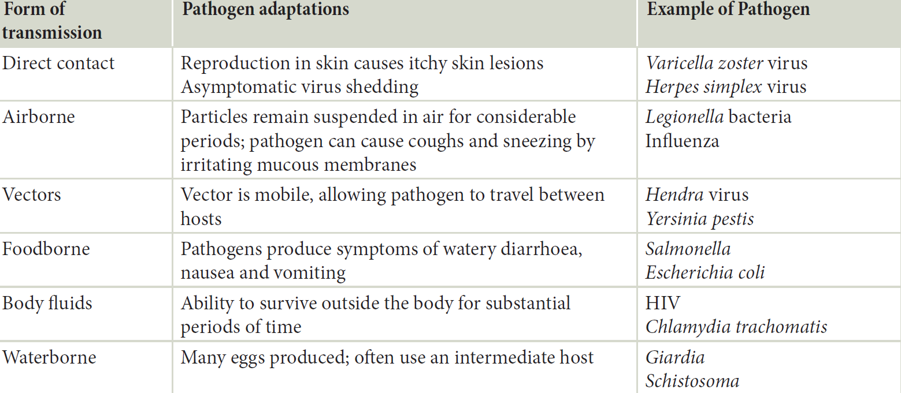
Pathogen Factors
- Infectivity:
  - Ability of pathogen to spread from host to host.
  - Disease with high infectivity spread quickly through pop. (EG: Measles)
- Virulence
  - Capacity of pathogen to cause severe disease in host
  - EG: Rabies kill all infected by virus once symptoms begin.
  - Virulent disease may have low infectivity & vice versa.
- Natural history of pathogen
  - Different stages of infection of a disease
  - influences how a disease spreads through pop.
- Persistence of pathogen
  - Within hosts or intermediate hosts.
  - Can persist in asymptomatic (show no symptoms) carriers who are still capable of transmitting infection to others
Environmental Factors
- Infrastructure & climate
  - A fresh water supply & good sewerage system can help reduce spread of disease
  - If major environmental disaster (tsunami) compromises infrastructure, causes lack of access to clean water & fresh food
  - Breakouts of diseases such as typhoid can occur
Host Factors
- Dense Pop
  - ppl more close proximity
  - disease spread more rapidly
- National & international travel
  - infected can travel great distances in relatively short periods of time & infect others
- Immunisation
  - Effective immunisation programs adversely affect spread
- High risk groups
  - Weaker immune systems eg: Elderly and sick
  - Disease tends to spread more rapidly

PREVENTING THE SPREAD OF DISEASE
- Hand-washing
  - reduces infection rates, prevents contraction and prevents the spread of disease, especially diseases that are spread by direct contact.
  - nosocomial infections (infections spread by healthcare workers) are extremely serious in their morbidity and mortality, therefore, hand-washing is an effective strategy.
- Immunisation
  - Intro of vaccine into an organism that contains dead or weakened pathogen
  - provides immunity against specific disease
  - a form of disease control administered orally, injection, patches
  - interrupts or stops the spread of disease,
  - eradication of disease can occur (e.g. smallpox).
- Herd immunity
  - When a large enough proportion of a population is immunised to stop spread of disease
  - Those not immune protected to an extent
  - Unvaccinated unlikely to come in contact with infected
  - greater proportion of population vaccinated, greater protection for those not
  - loss of herd immunity:
    - proportion of susceptible people increases in population, leading to disease outbreak.
    - Mutations in non-vaccinators can lead to pathogen resistance
- Anti-vaccinators
  - object immunisation of children with varying reasons:
  - false reports outlined that measles vaccines were linked to autism, therefore vaccination rates dropped substantially (scientific evidence disproves the link);
  - vaccinations can lead to severe reactions (this is rare, however).
- Quarantine
  - stops individuals carrying a disease from entering healthy populations
  - individuals are stopped from entering until the incubation period has passed
  - used to prevent spread of all pathogens.
- Disruption of pathogen life cycle
  - if spread by vector, transmission can be interrupted if vector is eradicated
- Medication- antibiotics & antivirals
  - medications used to kill bacteria or viruses.
  - When ppl successfully treated of infectious disease; usually results in reduced transmission
  - Antibiotics only work on living things like bacteria by preventing bacterial replication
  - Antivirals can only work on viruses by stopping viral replication
- Physical preventative measures
  - Isolation of patients
  - health workers at risk, wear gloves & special clothing
  - disposal of soiled bedding & clothing
  - Early diagnosis
METHODS MAY BE INEFFECTIVE
Quarantine
- Diseases may enter countries due to:
  - inadequate checks at customs
  - borders permeable to human movements
  - illegal activities & ignorance of travellers
Immunisation
- If large amount of pop. decide not to have treatment for themselves, large proportion of pop. at risk
- resistant strains can develop in circumstances that can affect vaccination
Disruption of pathogen life cycle
- Eradication programs cannot remove vector entirely
- Insects become resistant to insecticides
Medications
- Pathogens freq. develop resistance to drugs
Physical preventative measures
- transfer can still occur to those close to patients
  - occur through error or ignorance of disease
MONITORING DISEASE ACTIVITY

- In order to define and control disease outbreaks, public health authorities need to know when/where particular infections are occurring.
- Disease is actively and globally monitored by the World Health Organisation (WHO).
- In Australia, a list of 70 notifiable diseases must be reported and notified of diagnosis.
- There are limitations of collecting data:
  - Not all patients infected with disease will seek health care
  - Not all patients will receive diagnosis
  - Infections can be under-reported
  - Can be delay between onset of symptoms, diagnosis & reporting, limiting ability of public health authorities to respond quickly to epidemics
- Widespread use of internet & social media provides novel data source from which info about frequency of diseases can be extracted

MANAGING AN OUTBREAK
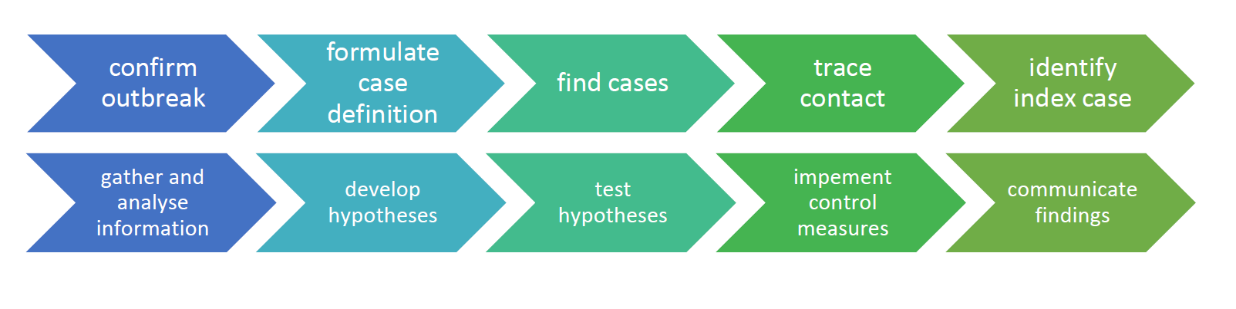
- investigate cases to ensure they meet definition of outbreak
- investigators formulate case definition of which cases are considered part of outbreak
- find cases
- gather info
- form hypotheses (3-5 easiest if disease transmission already known)
- find people affected by outbreak through contact tracing, may track down index case
- gather info from cases through extensive interviews ie questions of usual activity, sick contacts, recent meals, travel. Aim to generate hypothesis
- Interviewers can search for evidence to support or refute hypothesis- amy require further interviews, site inspections, environmental sampling or analysis of collected data.
- implement control measures
- communicate findings
PREDICTING DISEASE SPREAD
- Mathematical models can predict the spread of disease and are important in controlling outbreaks. Such tools can:
- be used to explore the likely effects of newly emerging pathogens & changes in environmental conditions.
- design & predict effects of potential public health interventions
- For a model to have good predictability, it needs to:
Reflect the complexity of the pathogen
Consider the host, pathogen and environmental interrelationships

EPIDEMIOLOGY
- Epidemiology is the branch of medicine that deals with the distribution, incidence and control of disease.

- Though there are improvements in prevention and treatment, infectious diseases are still a major cause of death globally.

Types of Diseases
Malaria

Scientific names
- Plasmodium falciparum
- Plasmodium malariae

Common name
Malaria

Type of Pathogen
Protozoan parasite

Structure of the Pathogen
- Single celled protist
- consist of a nucleus (contains DNA), a mitochondrion, microtubules (for moving proteins and other molecules) and an apicoplast, which is a organ unique to this group of single-celled parasites which is thought to be implicated in the invasion of host cells.
- The surface of the organism is covered in different proteins, some of which are used for binding to target host cells.

Method of Invading Host
- Transferred through the bite of a female mosquito from the genus Anopheles.
- Parasites (known as sporozoites at this stage) are found in mosquito's saliva, and transferred when bite occurs due to mingling of saliva and blood.
- Once in bloodstream, parasites travel to the liver cells where they mature and reproduce (mature parasites known as merozoites).
- Merozoites reproduce as sexually through blood schizogony, producing between 8-24 more merozoites before they burst from the cell, beginning the infective cycle anew.

Impact on the Host
- Fever and flu-like illness, including shaking chills, headache, muscle aches, and tiredness
- Nausea
- Vomiting
- Diarrhoea
- Anaemia and jaundice (yellow coloring of the skin and eyes) because of the loss of red blood cells
- Kidney failure
- Seizures
- Mental confusion
- Coma
- Death

Survival Success
- The death rate for malaria is approximately 0.002%, leaving a 99.998% chance of surviving successfully.

Treatments/Cures
- Anti-parasitics
- Anti-biotics

Crown Gall of Plants

Scientific name
- Agrobacterium tumefaciens

Common name
- Crown Gall of Plants

Type of Pathogen
- Gram-negative bacteria

Structure of the Pathogen
- Have a flagella to swim through soil and find plants to infect.
- Contain pili called T-Pilus which transfer genetic information to host
- Rod shaped
- Plasmid containing T-DNA

Method of Invading Host
- Attaches to plant cell & transfers genetic material (T-DNA) as a plasmid
- T-DNA (genes) enter nucleus & incorporates/inserts into plant chromosomal DNA
- Plant produces enzymes that bacteria consume
- Leads to tumour growth

Impact on the Host
- There may be no visible effect on the plant other than the galls (tumors)
- The galls are at first cream-coloured or greenish and later turn brown or black.
- However, if infection is severe and many galls are present, plants, particularly young ones, may be stunted and unthrifty and may die if they are stressed by dry conditions.

Survival Success
- Plants generally survive the disease, though some plants may become stunted and die if stressed by dry conditions.

Treatments/Cures
- There is no cure for Crown Gall Disease.

Phytophthora Dieback

PATHOGEN NAME
Scientific: Phytophthora cinnamomi

TYPE OF PATHOGEN
Fungus

STRUCTURE OF PATHOGEN
Zoospores: 2 tail-like flagella that allow spores to swim in water to reach a new host plant.

METHOD OF INVADING HOST
•Water mould in soil and plant tissue
•When suitable (warm & moist conditions) zoospores travel to and infect roots
•Mycelia grow through root ‐ absorbing carbs and water
•Release more zoospores: infects neighbouring plant

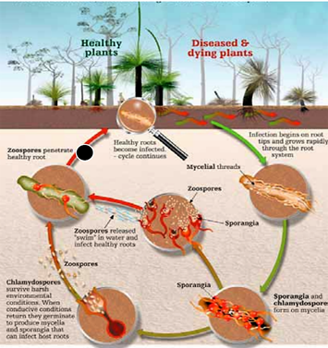

IMPACT ON THE HOST- SIGNS/SYMPTOMS, DISRUPTION TO BODY FUNCTIONS
•Wilting
•Discoloration (usually red or yellow)
•Foliage dries out
•Young feeder roots darken
•It causes root rot which limits/stops uptake of water and nutrients.

MODE OF TRANSMISSION/SPREAD (DIRECT OR INDIRECT ETC)
•Spreads from plant to plant through root contact.
•Transmitted by spores through soil & water
•Spreads most rapidly when rainfall coincides with warm temperatures.
•Can be spread through human activities, eg: road building, timber harvesting, mine exploration, nursery trade and bushwalking.

SURVIVAL SUCCESS
Most plants do not survive as the disease causes the inability to get adequate water and nutrients. Some however can survive the disease.

TREATMENTS/CURES
- There is no cure for Phytophthora nor is there a way of stopping the spread once it has infested the area.
- The only way to combat the disease is to limit the spread of the fungus and reduce its impact. This is achieved with management plans such as quarantine, hygiene and treatment with chemical phosphite.

Australian bat lyssavirus

PATHOGEN NAME
Australian bat lyssavirus

TYPE OF PATHOGEN
Virus

STRUCTURE OF PATHOGEN
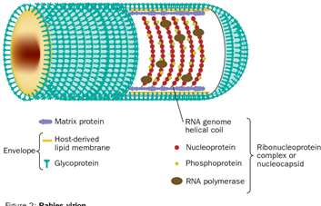
Made up of proteins and RNA

METHOD OF INVADING HOST
•Virus host cell attaches to host receptors
•Virus multiples
•Virus move on and attach to other nerve cells until they get to the brain.
•Virus causes brain to swell.

IMPACT ON THE HOST- SIGNS/SYMPTOMS, DISRUPTION TO BODY FUNCTIONS
- Early symptoms are flu-like; headache, fever and fatigue.
- Progresses rapidly to paralysis, delirium, convulsions and death.

MODE OF TRANSMISSION/SPREAD (DIRECT OR INDIRECT ETC)
•Direct
•By vector, bats.
•Spread through bites or scratches or by being exposed to infected animals’ saliva through the eyes, nose, mouth, or broken skin.

SURVIVAL SUCCESS

There is not enough information to determine an exact survival rate, but it is currently estimated to be 8%.

TREATMENTS/CURES

•No specific treatment available for ABLV.
•Proper cleansing of wound reduces risk of infection
•Antiseptic with anti-virus action such as alcohol should be applied after washing
•Vaccination to ABLV is available both pre and post exposure

Tuberculosis

Pathogen name
mycobacterium tuberculosis.

Type of pathogen
bacteria (germ) =intracellular parasite.

Structure of the pathogen
- Rod shaped bacterium.
- Has a tough cell wall that prevents passage of nutrients into and excreted from the cell, therefore giving it the characteristics of slow growth rate.
- Flagellum, facilitate movement

Method of invading host
- After being ingested from the air by macrophages, the mycobacterium tuberculosis enters the host.
- Once the bacteria is spread, tuberculosis grows in the throat and lungs after 2-8 weeks of infection.
- The bacteria has special mechanisms for cell entry, binding directly with receptors on macrophages

Impact on host
In humans:
- chronic cough
- coughing blood
- lethargy
- sweating
- loss of weight

Mode of transmission
- TB is spread by droplet transmission, via the air when contaminated patient sneezes or coughs.
- If exposed to a contaminated person, one can acquire TB by breathing bacteria in the air.
- It is mainly through long-term contact with an infected person.
- Not spread by household items.

Survival success
- Causes no illness in 90-95 percent of infected people.
- TB is one of the top 10 causes of death worldwide.
- People infected with TB bacteria have a 5 to 15% lifetime risk of falling ill with TB.
- TB kill thousands everyday.
- 70% successful treatment.

Treatment/cures
- TB infection- doctor may prescribe a course of tablets (preventative therapy) follow up with regular chest X-rays.
- TB disease-treated with a combination of special antibiotics for at least six months.
- People with TB can be cured if they complete treatment.

Ross river virus

Pathogen name
- group of viruses called arbo viruses (or arthropod-borne viruses)

Type of pathogen
- virus

Structure of the pathogen
the virus is characterised by the presence of two glycoproteins (E1 and E2) embedded as trimeric diners in a host-derived lipid envelope

Method of invading a host
female mosquitoes feed on animals and people. If they feed on the blood of an infected animal, the mosquito may become infected. The virus then multiplied within the mosquito and is passed to other animals or people when the mosquito feeds again.

Impact on the host
- flu like symptoms that include fever, chills, headache and aches and pains in the muscles and joints
- joints can become swollen, and joint stiffness may become particularly noticeable in the morning
- Sometimes a rash occurs on the body, arms or legs
- A general feeling of being unwell, tired or weak
- Although many people who are infected with the virus will never develop symptoms

Mode of transmission/spread
- The virus is not spread directly from one person to another. RRV is passed back and forth between animals and mosquitos. People can only catch these viruses after being bitten by an infected mosquito

Survival success
- Ross river virus can leave people bedridden for up to six weeks, however it doesn’t usually result in death

Treatment/cure
- There is currently no vaccine against Ross river virus and there is no specific treatment for it.
- Antivirals

Tetanus

Pathogen name
Clostridium tetani

Type of Pathogen
Bacteria

Structure of the pathogen
- thick cell wall made up of multiple layers of and one inner membrane.
- C. tetani are mobile bacteria and move by the means of rotary flagellum.
- C. tetani in the presence of oxygen changes into its endospore (drum stick shaped) formation

Method of invading host
- Spores of the bacteria that cause tetanus are found in soil, dust and animal feces.
- When they enter a deep flesh wound, spores grow into bacteria that can produce a powerful toxin, which impairs the nerves that control your muscles (motor neurons).

Impact on the host
- Painful muscle spasms that begin in the jaw (lock jaw)
- Stiff neck, shoulder and back muscles
- Difficulty swallowing
- Violent generalised muscle spasms
- Convulsions
- Breathing difficulties
- A person may develops a fever and abnormal heart rhythms. Complications include pneumonia, broken bones (from the muscle spasms), respiratory failure and cardiac arrest

Mode of transmission/spread
- Tetanus is not passed on from one person to another
- neonatal tetanus (affecting new born babies) can occur in babies due to inadequately immunised mothers, especially after unsterile treatment of the umbilical cord stump
- Otherwise, host is infected when dirts enters a wound or cut

Survival success
- In developing countries, the mortality from tetanus exceeds 50% .
- In the developed world, with intensive care support, mortality is around 10%, rising to 20% in severe cases.

Treatments/cures
- Treatment may include antitoxin, antibiotics, surgical treatment of the infected area and prolonged treatment in the intensive care unit of a hospital
- It can also be prevented by the Tetanus vaccine which is given at 2, 4 and 6 months of age, with boosting doses at 4 years, and between 12 to 17 years

Sacbrood
Pathogen name
sacbrood virus (SBI).

Type of pathogen
virus

Method of invading host:
- Larvae thought to be infected by consuming brood food contaminated with sacbrood virus.
- The virus then multiplies within the infected larvae the skin of the larvae and gradually becomes a fluid-filled sac. the sacral virus may remain viable in dead larvae, honey or pollen for up to 4 weeks.
- In the process of infecting or feeding on the bee larvae or adult bee, nosema or varroa mites would appear to create an opportunity for viral particles to enter the body of the Bee.

Signs and symptoms:
Larvae dies just before pupation begins.
Dead larvae initially contained in a watery bag.
Larvae Dies along the base of the cell in a banana or gondola shape.
Larvae takes on a light brown appearance.
Dead larvae turns dark brown
Outer skin of dead larvae toughens.

Mode of transmission:
- irect
- Spread through feeding behaviour.
- Consuming brood food contaminated with SBV.
- Spread through parasites mites.

Black queen virus:

Pathogen name
Trietovirus

Type of pathogen
virus

Method of invading host:
Stimulated by lower than ideal temperatures in artificial cell incubators.
Primarily attacks developing queens.
The virus is typically detached by polymerase chain reaction.

Signs and symptoms:
- Dead Queen larvae.
- Larvae/pupae turn pale yellow with tough skin at first similar to the sacbrood virus but only in Queen larvae.
- Dead larvae become dark brown to Black.

Mode of transmission:
Water and related beekeeping equipment may also carry the virus and cause transmission between.

Kashmir bee virus:

Pathogen name
cripavirus

Type of pathogen
virus

Method invading host
- The virus usually develops in bee families affected by the varroa mite.
- they might have the ability to transmit viruses due to piercings they make into a cuticle of adult.

Signs and symptoms:
- Reduced lifespan of infected bees.
- Apart parts of thorax very dark coloured.
- Hair loss.
- Young bees have an opaque look.

Mode of transmission:
- Through food feeding any type of contact with infected bees.
- Queen bee also passes disease to the brood by means of a trans ovarian route.
- Nosema + acarapis woodi also responsible.

Paralysis virus:

Pathogen name
apis mallifera.

Type of pathogen
virus.

Method of invading host:
Pesticide poisoning, through nosema disease.

Signs and symptoms:

- Trembling.
- Tend to crawl about the entrance of the Hive or on grass stems near the hive.
- Can cluster together on the ground or on stems.
- Abdomen can appear enlarged with dislocated wings.
- Become hairless, dark to shiny black in colour.
- Paralysis.
- Greasy, hairless, black adult bees that can fly.
- Within a few days become flightless, trembling and soon die.

Mode of transmission:
Primarily occurs through direct body contact, although oral transmission also occurs it is much less virulent.

Pathogen structure:
contains 60 copies of a minor capsid protein attached to it's surface.
Crystal structure.
Contains nucleic acid (DNA or RNA-not both) and a protein coat which encases the nucleic acid.

Survival success:
Once a bee is infected it will die.

Treatment:
Requeening infected colonies and improving the nutrition of The Colony by providing sugar syrup and pollen

Chytridiomycosis (amphibian chytrid fungal disease)
Scientific name
Batrachochytrium dendrobatidis
Type
Fungus
Structure
- General fungal structure - Structure of fungi.
- The main body of most fungi is made up of fine, branching, usually colourless threads called hyphae.
- Each fungus will have vast numbers of these hyphae, all intertwining to make up a tangled web called the mycelium.
Method of invading host
Absorbing in the pathogen through fungal spores
Impact on host
capable of causing sporadic deaths in some amphibian populations and 100 per cent mortality in others.
Mode of transmission
- Chytrid fungus is probably transferred by direct contact between frogs and tadpoles, or through exposure to infected water. The disease may not kill frogs immediately, and they can swim or hop to other areas before they die, spreading fungal spores to new ponds and streams
Survival success
- Mortality rates in laboratory infection experiments can range from 0% to 100%, depending on the species
Treatment
- Itraconazole baths have been used successfully in rescue operations that capture wild amphibians from populations that are experiencing deaths to chytridiomycosis (Gagliardo et al., 2008). Other potential treatment methods include the use of elevated body temperature and paradoxically, the antibiotic chloramphenicol.

Influenza

Pathogen name
influenza A virus

Type of pathogen
virus

3. Structure of pathogen
The influenza virion (as the infectious particle is called) is roughly spherical. It is an enveloped virus – that is, the outer layer is a lipid membrane which is taken from the host cell in which the virus multiplies

4. Method of invading host:

When the influenza virus infects a host cell its goal is to produce many duplicates of itself that go on to attack even more cells. The viral polymerase binds to host cell mRNA via its cap, cuts the cap off and adds it to the beginning of its own mRNA – a process known as 'cap snatching'.

5. Impact on the host:
Symptoms:
- fever
- chills
- muscle aches
- cough
- congestion
- runny nose
- headaches
- fatigue

People may experience:

Pain areas: in the muscles
Cough: can be dry or with phlegm
Whole body: chills, dehydration, fatigue, fever, flushing, loss of appetite, body ache, or sweating
Nasal: congestion, runny nose, or sneezing
Also common: chest pressure, head congestion, headache, nausea, shortness of breath, sore throat, or swollen lymph nodes

6. Mode of transmission:
- by direct contact with infected individuals
- by contact with contaminated objects (called fomites)
- by inhalation of virus-laden aerosols

7. Survival success:
“influenza A results in the most complications and fatalities, and of A strains, H3N2 is the most severe. A notable exception is the H1N1pdm09, of which a distinct lineage in South Asia has been causing severe disease and an apparent case fatality rate of 6% or higher”

8. Treatment:
- primarily with rest and fluid to let the body fight the infection on its own. Over-the-counter anti-inflammatory pain relievers may help with symptoms. An annual vaccine can help prevent the flu and limit its complications

Biotechnology environmental conservation:

- Monitoring endangered species: biobanking- keeping samples of endangered- seed banks, tissue samples.
- assessing gene pools for breeding programs: genetic testing can measure degree of genetic diversity in a population.
- quarantine: prevents introduction of non-indigenous animals and plants that could potentially with native species.

Molecular evidence for evolution through similarities
Comparative genomics:
the genomic features of different organisms are compared
common features of two organisms will often be encoded within the DNA that is evolutionarily conserved between them.
Compare:
- DNA sequences
- Genes
Comparative biochemistry
study of the basic chemistry and processes that occur in cells. It involves the comparison of DNA, proteins and chromosomes across different species.
- same genes, slight differences
- similar number of chromosomes
Bioinformatics
science of managing & analyzing biological data using advanced computing techniques

Binary Fission
- Genetic material is replicated
- Duplicated genetic materials moves to opposite end of cell
- Each copy of duplicated chromosome attaches to a different part of the cell membrane
- Cell divides into two daughter cells via cytokinesis
- New cell wall is laid down
- Each daughter cell has a copy of chromosome/genetic material/is identical to the parent

Examples of DNA methylation
X-inactivation:
- Females have two X chromosomes and males only have one X chromosome.
- 1 One of the X chromosomes is inactivated in every cell. This prevents female cells from producing double the amount of protein required.
Imprinting:
- version of gene silencing
- one of the 2 alleles of a gene inherited from each parent is silenced via methylation

